d1 Short for electronic mail, the transmission of messages over communications networks. The messages can be notes entered from the keyboard or electronic files stored on disk. Most mainframes, minicomputers, and computer networks have an e-mail system. Some electronic-mail systems are confined to a single computer system or network, but others have gateways to other computer systems, enabling users to send electronic mail anywhere in the world. Companies that are fully computerized make extensive use of e-mail because it is fast, flexible, and reliable.Most e-mail systems include a rudimentary text editor for composing messages, but many allow you to edit your messages using any editor you want. You then send the message to the recipient by specifying the recipient's address. You can also send the same message to several users at once. This is called broadcasting.Sent messages are stored in electronic mailboxes until the recipient fetches them. To see if you have any mail, you may have to check your electronic mailbox periodically, although many systems alert you when mail is received. After reading your mail, you can store it in a text file, forward it to other users, or delete it. Copies of memos can be printed out on a printer if you want a paper copy.

d2 messages distributed by electronic means from one computer user to one or more recipients via a network

d3 is a method of exchanging digital messages from an author to one or more recipients. Modern email operates across the Internet or other computer networks. Today's email systems are based on a store-and-forward model. Email servers accept, forward, deliver, and store messages. Neither the users nor their computers are required to be online simultaneously; they need connect only briefly, typically to a mail server, for as long as it takes to send or receive messages. An Internet email message consists of three components, the message envelope, the message header, and the message body. The message header contains control information, including, minimally, an originator's email address and one or more recipient addresses. Usually descriptive information is also added, such as a subject header field and a message submission date/time stamp. Email is an information and communications technology. It uses technology to communicate a digital message over the Internet.

d4 Messages and other data exchanged between individuals using computers in a network. An e-mail system allows computer users to send text, graphics, and sometimes sounds and animated images to other users.

d5 E-mail is part of the standard TCP/IP set of protocols. Sending messages is typically done by SMTP (Simple Mail Transfer Protocol) and receiving messages is handled by POP3 (Post Office Protocol 3), or IMAP (Internet Message Access Protocol). IMAP is the newer protocol, allowing you to view and sort messages on the mail server, without downloading them to your hard drive.Though e-mail was originally developed for sending simple text messages, it has become more robust in the last few years. Now, HTML-based e-mail can use the same code as Web pages to incorporate formatted text, colors, and images into the message. Also, documents can be attached to e-mail messages, allowing files to be transferred via the e-mail protocol. However, since e-mail was not originally designed to handle large file transfers, transferring large documents (over 3 MB, for example) is not allowed by most mail servers. So remember to keep your attachments small!

d7 a system for sending messages from one individual to another via telecommunications links between computers or terminals.

Short for **e**lectronic **mail**,  the transmission**** of messages and other data exchanged between individuals using computers**** to communicate a digital message over the Internet****. 

The messages can be notes entered from the keyboard or electronic files stored on storage devices.

The message is sent to the recipient by specifying the recipient's address. The same message can also be sent to several users 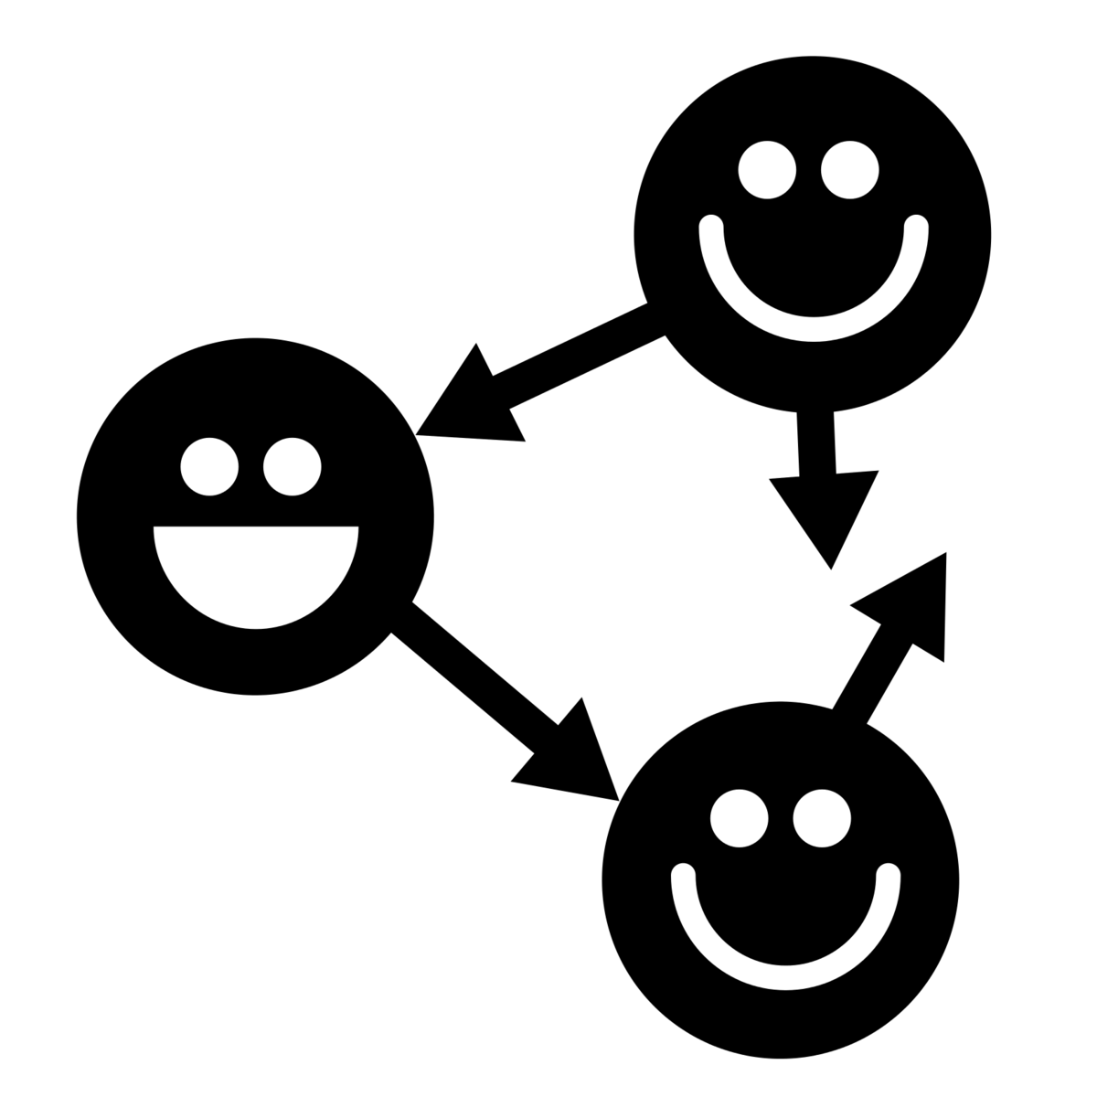 at once.

Today's email systems are based on a store-and-forward model. Email servers accept, forward, deliver, and store messages. Neither the users nor their computers are required to be online simultaneously.